גוגל-נט

1) https://d2l.ai/chapter_convolutional-modern/googlenet.html

7.4. Networks with Parallel Concatenations (GoogLeNet) COLAB

Open the notebook in Colab
In 2014, [Szegedy et al., 2015] won the ImageNet Challenge, proposing a structure that combined the strengths of the NiN and repeated blocks paradigms. One focus of the paper was to address the question of which sized convolutional kernels are best. After all, previous popular networks employed choices as small as 1×11×1 and as large as 11×1111×11. One insight in this paper was that sometimes it can be advantageous to employ a combination of variously-sized kernels. In this section, we will introduce GoogLeNet, presenting a slightly simplified version of the original model—we omit a few ad hoc features that were added to stabilize training but are unnecessary now with better training algorithms available.

7.4.1. Inception Blocks
The basic convolutional block in GoogLeNet is called an Inception block, likely named due to a quote from the movie Inception (“We Need To Go Deeper”), which launched a viral meme.

Fig. 7.4.1 Structure of the Inception block.
As depicted in the figure above, the inception block consists of four parallel paths. The first three paths use convolutional layers with window sizes of 1×11×1, 3×33×3, and 5×55×5 to extract information from different spatial sizes. The middle two paths perform a 1×11×1 convolution on the input to reduce the number of input channels, reducing the model’s complexity. The fourth path uses a 3×33×3 maximum pooling layer, followed by a 1×11×1 convolutional layer to change the number of channels. The four paths all use appropriate padding to give the input and output the same height and width. Finally, the outputs along each path are concatenated along the channel dimension and comprise the block’s output. The commonly-tuned parameters of the Inception block are the number of output channels per layer.
import d2l
from mxnet import np, npx
from mxnet.gluon import nn
npx.set_np()

class Inception(nn.Block):
# c1 - c4 are the number of output channels for each layer in the path
def __init__(self, c1, c2, c3, c4, **kwargs):
super(Inception, self).__init__(**kwargs)
# Path 1 is a single 1 x 1 convolutional layer
self.p1_1 = nn.Conv2D(c1, kernel_size=1, activation='relu')
# Path 2 is a 1 x 1 convolutional layer followed by a 3 x 3
# convolutional layer
self.p2_1 = nn.Conv2D(c2[0], kernel_size=1, activation='relu')
self.p2_2 = nn.Conv2D(c2[1], kernel_size=3, padding=1,
activation='relu')
# Path 3 is a 1 x 1 convolutional layer followed by a 5 x 5
# convolutional layer
self.p3_1 = nn.Conv2D(c3[0], kernel_size=1, activation='relu')
self.p3_2 = nn.Conv2D(c3[1], kernel_size=5, padding=2,
activation='relu')
# Path 4 is a 3 x 3 maximum pooling layer followed by a 1 x 1
# convolutional layer
self.p4_1 = nn.MaxPool2D(pool_size=3, strides=1, padding=1)
self.p4_2 = nn.Conv2D(c4, kernel_size=1, activation='relu')

def forward(self, x):
p1 = self.p1_1(x)
p2 = self.p2_2(self.p2_1(x))
p3 = self.p3_2(self.p3_1(x))
p4 = self.p4_2(self.p4_1(x))
# Concatenate the outputs on the channel dimension
return np.concatenate((p1, p2, p3, p4), axis=1)

To gain some intuition for why this network works so well, consider the combination of the filters. They explore the image in varying ranges. This means that details at different extents can be recognized efficiently by different filters. At the same time, we can allocate different amounts of parameters for different ranges (e.g., more for short range but not ignore the long range entirely).

7.4.2. GoogLeNet Model
As shown in Fig. 7.4.2, GoogLeNet uses a stack of a total of 9 inception blocks and global average pooling to generate its estimates. Maximum pooling between inception blocks reduced the dimensionality. The first part is identical to AlexNet and LeNet, the stack of blocks is inherited from VGG and the global average pooling avoids a stack of fully-connected layers at the end. The architecture is depicted below.

Fig. 7.4.2 Full GoogLeNet Model
We can now implement GoogLeNet piece by piece. The first component uses a 64-channel 7×7 convolutional layer.
b1 = nn.Sequential()
b1.add(nn.Conv2D(64, kernel_size=7, strides=2, padding=3, activation='relu'),
nn.MaxPool2D(pool_size=3, strides=2, padding=1))

The second component uses two convolutional layers: first, a 64-channel 1×11×1 convolutional layer, then a 3×33×3 convolutional layer that triples the number of channels. This corresponds to the second path in the Inception block.
b2 = nn.Sequential()
b2.add(nn.Conv2D(64, kernel_size=1, activation='relu'),
nn.Conv2D(192, kernel_size=3, padding=1, activation='relu'),
nn.MaxPool2D(pool_size=3, strides=2, padding=1))

The third component connects two complete Inception blocks in series. The number of output channels of the first Inception block is 64+128+32+32=25664+128+32+32=256, and the ratio to the output channels of the four paths is 64:128:32:32=2:4:1:164:128:32:32=2:4:1:1. The second and third paths first reduce the number of input channels to 96/192=1/296/192=1/2 and 16/192=1/1216/192=1/12, respectively, and then connect the second convolutional layer. The number of output channels of the second Inception block is increased to 128+192+96+64=480128+192+96+64=480, and the ratio to the number of output channels per path is 128:192:96:64=4:6:3:2128:192:96:64=4:6:3:2. The second and third paths first reduce the number of input channels to 128/256=1/2128/256=1/2 and 32/256=1/832/256=1/8, respectively.
b3 = nn.Sequential()
b3.add(Inception(64, (96, 128), (16, 32), 32),
Inception(128, (128, 192), (32, 96), 64),
nn.MaxPool2D(pool_size=3, strides=2, padding=1))

The fourth block is more complicated. It connects five Inception blocks in series, and they have 192+208+48+64=512192+208+48+64=512, 160+224+64+64=512160+224+64+64=512, 128+256+64+64=512128+256+64+64=512, 112+288+64+64=528112+288+64+64=528, and 256+320+128+128=832256+320+128+128=832 output channels, respectively. The number of channels assigned to these paths is similar to that in the third module: the second path with the 3×33×3 convolutional layer outputs the largest number of channels, followed by the first path with only the 1×11×1 convolutional layer, the third path with the 5×55×5 convolutional layer, and the fourth path with the 3×33×3 maximum pooling layer. The second and third paths will first reduce the number of channels according the ratio. These ratios are slightly different in different Inception blocks.
b4 = nn.Sequential()
b4.add(Inception(192, (96, 208), (16, 48), 64),
Inception(160, (112, 224), (24, 64), 64),
Inception(128, (128, 256), (24, 64), 64),
Inception(112, (144, 288), (32, 64), 64),
Inception(256, (160, 320), (32, 128), 128),
nn.MaxPool2D(pool_size=3, strides=2, padding=1))

The fifth block has two Inception blocks with 256+320+128+128=832256+320+128+128=832 and 384+384+128+128=1024384+384+128+128=1024 output channels. The number of channels assigned to each path is the same as that in the third and fourth modules, but differs in specific values. It should be noted that the fifth block is followed by the output layer. This block uses the global average pooling layer to change the height and width of each channel to 1, just as in NiN. Finally, we turn the output into a two-dimensional array followed by a fully-connected layer whose number of outputs is the number of label classes.
b5 = nn.Sequential()
b5.add(Inception(256, (160, 320), (32, 128), 128),
Inception(384, (192, 384), (48, 128), 128),
nn.GlobalAvgPool2D())

net = nn.Sequential()
net.add(b1, b2, b3, b4, b5, nn.Dense(10))

The GoogLeNet model is computationally complex, so it is not as easy to modify the number of channels as in VGG. To have a reasonable training time on Fashion-MNIST, we reduce the input height and width from 224 to 96. This simplifies the computation. The changes in the shape of the output between the various modules is demonstrated below.
X = np.random.uniform(size=(1, 1, 96, 96))
net.initialize()
for layer in net:
X = layer(X)
print(layer.name, 'output shape:\t', X.shape)

sequential0 output shape: (1, 64, 24, 24)
sequential1 output shape: (1, 192, 12, 12)
sequential2 output shape: (1, 480, 6, 6)
sequential3 output shape: (1, 832, 3, 3)
sequential4 output shape: (1, 1024, 1, 1)
dense0 output shape: (1, 10)

7.4.3. Data Acquisition and Training
As before, we train our model using the Fashion-MNIST dataset. We transform it to 96×9696×96 pixel resolution before invoking the training procedure.
lr, num_epochs, batch_size = 0.1, 10, 128
train_iter, test_iter = d2l.load_data_fashion_mnist(batch_size, resize=96)
d2l.train_ch5(net, train_iter, test_iter, num_epochs, lr)

loss 0.261, train acc 0.900, test acc 0.893
2506.1 examples/sec on gpu(0)

7.4.4. Summary
- The Inception block is equivalent to a subnetwork with four paths. It extracts information in parallel through convolutional layers of different window shapes and maximum pooling layers. 1×11×1 convolutions reduce channel dimensionality on a per-pixel level. Max-pooling reduces the resolution.
- GoogLeNet connects multiple well-designed Inception blocks with other layers in series. The ratio of the number of channels assigned in the Inception block is obtained through a large number of experiments on the ImageNet dataset.
- GoogLeNet, as well as its succeeding versions, was one of the most efficient models on ImageNet, providing similar test accuracy with lower computational complexity.

2)https://leonardoaraujosantos.gitbooks.io/artificial-inteligence/content/googlenet.html

GoogleNet

Introduction

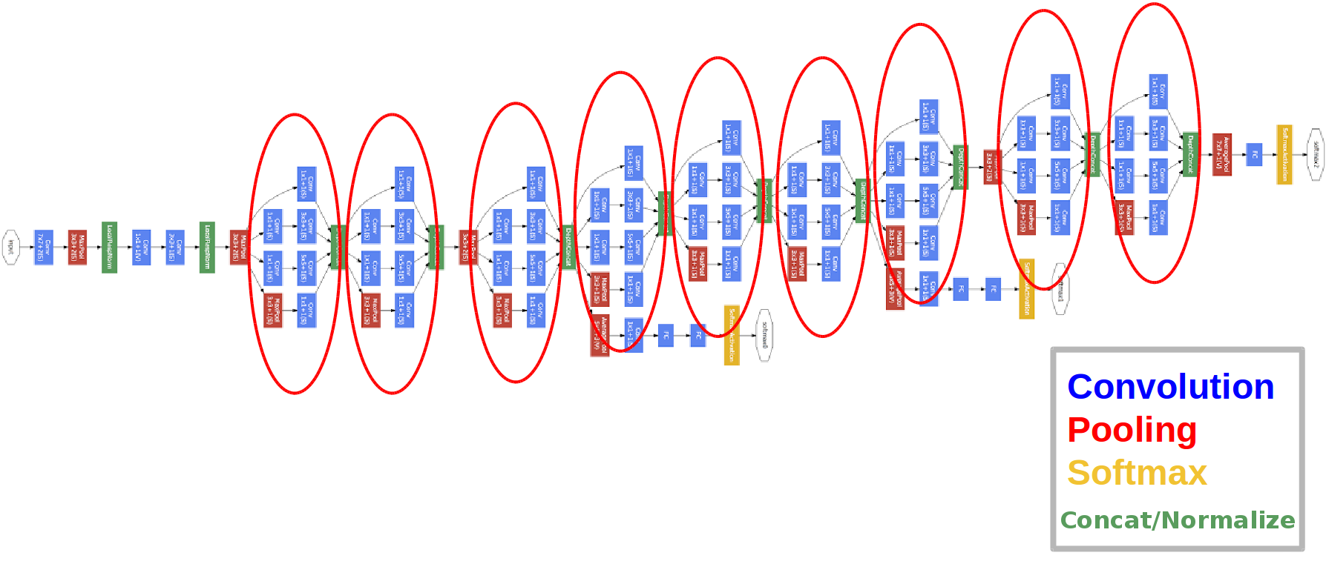
On this chapter you will learn about the googleNet (Winning architecture on ImageNet 2014) and it's inception layers.
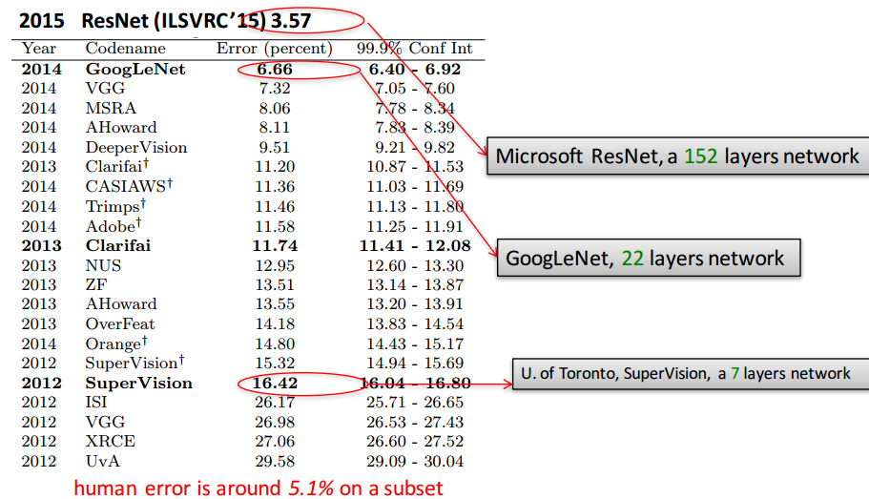
googleNet has 22 layer, and almost 12x less parameters (So faster and less then Alexnet and much more accurate.
Their idea was to make a model that also could be used on a smart-phone (Keep calculation budget around 1.5 billion multiply-adds on prediction).

Inception Layer

The idea of the inception layer is to cover a bigger area, but also keep a fine resolution for small information on the images. So the idea is to convolve in parallel different sizes from the most accurate detailing (1x1) to a bigger one (5x5).
The idea is that a series of gabor filters with different sizes, will handle better multiple objects scales. With the advantage that all filters on the inception layer are learnable.
The most straightforward way to improve performance on deep learning is to use more layers and more data, googleNet use 9 inception modules. The problem is that more parameters also means that your model is more prone to overfit. So to avoid a parameter explosion on the inception layers, all bottleneck techniques are exploited.
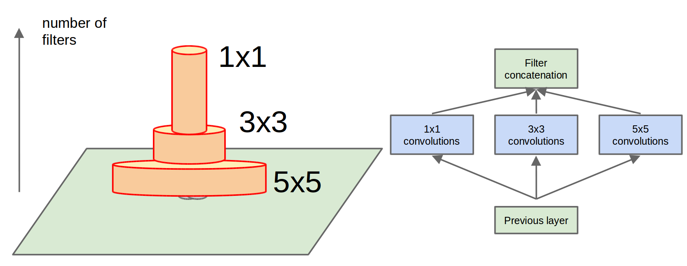
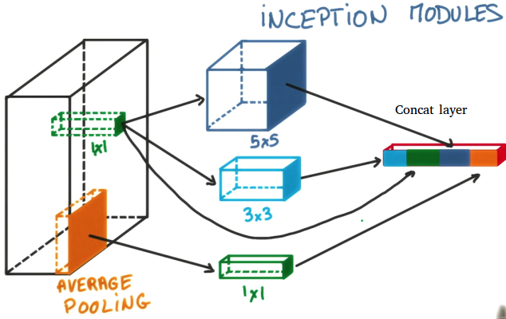
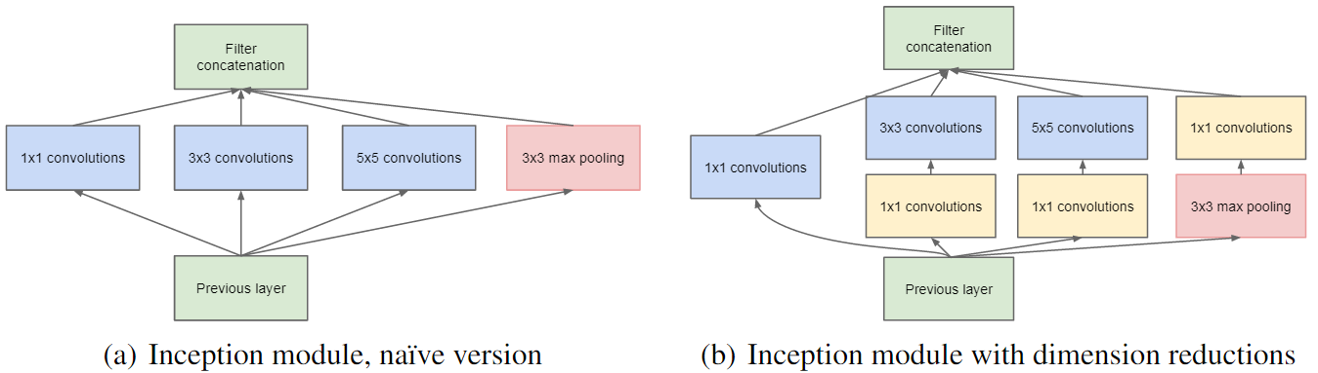
Using the bottleneck approaches we can rebuild the inception module with more non-linearities and less parameters. Also a max pooling layer is added to summarize the content of the previous layer. All the results are concatenated one after the other, and given to the next layer.

3) https://www.ai-blog.co.il/tag/inception/
בעברית- אבל חסר

n
11
JUN
2018

רשת הInception הקיצונית: Xception
מיועד ל- מטיבי לכת (כתבה מאוד טכנית)
נכתב על ידי תמיר נווה

רקע
רשתות Inception v4 ו Xception הינן מהרשתות הטובות ביותר כיום בזיהוי מה רואים בתמונה.
ב 2014 גוגל ניצחה בתחרות ILSVRC עם רשת GoogLeNet שהראתה לקהילה ארכיטקטורה חדשנית בשם Inception לפיה שכבות לאו דווקא חייבות להיות בטור אלא במקביל ואת תוצאותיהן משרשרים. השיטה הזו חסכה בזיכרון והביאה לביצועים הטובים ביותר דאז. מאז יצאו גירסאות נוספות שנקראות inception v2, v3, v4 או Inception-Resnet שמשלבת את הרעיון הזה של גוגל עם רעיון המעקפים של מיקרוסופט של רשת Resnet.
כל רשתות CNN=Convolution Neural Network מכילות פעולות קונבולוציה. ב 2016 יצאה רשת Xception שחידשה את פעולת הקונבולוציה ע”י כך שהיקצינה את מודל ה Inception.
בקונבולוציה רגילה יש עיבוד (סכום מכפלות) של הקלט והגרעין (הפילטר) בכל המימדים ביחד (המרחביים והצבע\ערוצים channels). הרעיון מאחורי מודל ה Inception הוא לבצע את העיבוד הזה בנפרד הן על המימדים המרחביים (x,y) והן על מימד העומק (הצבע אם מדובר בתמונה הראשונית). יש הגיון בכך אם חושבים על כך שבתמונה המימד המרחבי שונה מהותית ממימד העומק שהינו הצבעים שבתמונה, ויש טעם בלבנות פילטרים בלתי תלויים שפועלים כל אחד בתורו.
הרשת Xception (extreme inception) מקצינה את הרעיון הזה באמצעות פעולה שנקראת depthwise separable convolution.
כותב המאמר Xception הינו François Chollet שגם ידוע כיוצר של Keras!

טכני
בקונבולוציה רגילה, בעבור טנזור בגודל 6x6x3 נצטרך kernel בגודל nxnx3. נניח n=2 אז קובית ה kernel בגודל 2x2x3 נעה בכיוון x,y בלבד על פני הקוביה הגדולה של ה 6x6x3 ובכל מעבר סוכמים את המכפלות. מימדי העומק של הטנזור ושל הגרעין שניהם שווים (לשלוש בדוגמא זו) ולכן הקוביה הקטנה לא נעה בכיוון z.
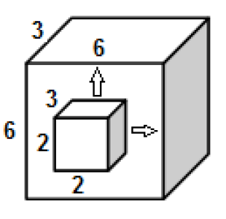
בקונבולוציה רגילה מימד העומק של הטנזור והגרעין זהים
בפעולת ה depthwise separable convolution לעומת זאת, יש שני שלבים, באחת הקוביה הקטנה נעה בכיוונים x,y ובשניה קוביה קטנה (אחרת) נעה בכיוון z.
ישנן גירסאות מימוש שונות, לפי המימוש המקובל (למשל ב Tensorflow) קודם מבצעים קונבולוציות מרחביות לכל ערוץ בנפרד (ז”א ה-kernel בגודל nxnx1) ואז מבצעים קונבולוציה למימד הערוץ ז”א מימד עומק (ה-kernel בגודל 1x1xc)
למשל, שורות הקוד הבאות מדגימות טנזור בגודל 6x6x3 שעובר separable conv עם פילטר מרחבי בגודל 3×3 ומכפיל את הערוצים פי 2 ועם פילטר “עומקי” שמגדיל 6 ערוצים ל 12 ערוצים:
x = tf.placeholder(tf.float32, [None, 6, 6, 3])
depthwise_filter = tf.get_variable(‘depthwise_filter’, shape=[3, 3, 3, 2])
pointwise_filter = tf.get_variable(‘pointwise_filter’, shape=[1, 1, 6, 12])
y = tf.nn.separable_conv2d(x,depthwise_filter, pointwise_filter, strides=[1, 1, 1, 1], padding=‘SAME’)

והתוצאה הינה טנזור בגודל:
?x6x6x12
(? מייצג את גודל ה batch)
ארכיטקטורת Xception כפי במוצגת במאמר כוללת שלושה מרכיבים: middle, entry, exit הכוללים בעיקר פעולות Seperable Conv, ReLu, MaxPooling:
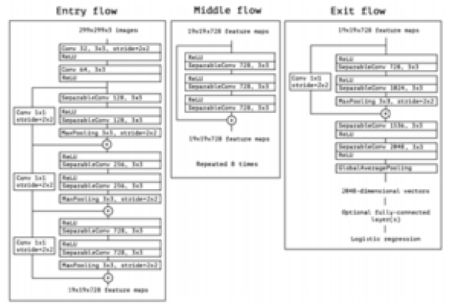
תודה ל Xception

תוצאות
באותו מאמר הם מציגים ביצועים על מאגר ImageNet (מאגר של עשרות מיליוני תמונות עם אלף מחלקות).
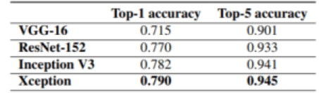
תודה ל xception
ותוצאות על FastEval14K (מאגר של 14,000 תמונות עם 6,000 מחלקות) כאשר הרשת אומנה על JFT (מאגר פנימי של גוגל של 350 מיליון תמונות עם 17,000 מחלקות):
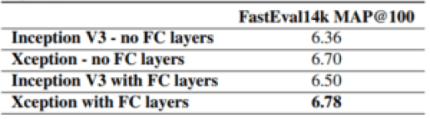
תודה ל xception

כמו כן הרשת MobileNet (רשת קלה וקומפקטית שרצה על מובייל) מבוססת על Xception.

קישורים
מימוש Xception ב Tensorflow:
https://github.com/kwotsin/TensorFlow-Xception
מימוש Xception ב Keras:
https://github.com/keras-team/keras/blob/master/keras/applications/xception.py
Posted by תמיר נווה in DEEP
07
MAR
2018

מה רואים בתמונה ? המסע שהחל ב-Alexnet והגיע עד רשתות הקפסולות
מיועד ל- כל אחד (כתבה לא טכנית)
נכתב על ידי תמיר נווה
סנונית מהפיכת הלמידה העמוקה הגיעה ב 2012 עם תוצאה טובה באופן משמעותי בתחרות זיהוי אוביקטים השנתית שנקראת ILSVRC. לראשונה אלגוריתם מבוסס רשת נוירונים עמוקה שנקרא Alexnet היצליח לזהות מה רואים במיליוני תמונות ברמת הצלחה של 85% בעוד המקום השני בתחרות דאז הגיע ל 74% הצלחה.
מאז ועד היום כל זוכי התחרות הזו משתמשים ברשתות נוירונים עמוקות (מה שכלל לא נחשב כ- main stream לפני), ולמעשה מיום ליום מסתבר שלמידה עמוקה מצליחה לא רק לבעיות ראייה ממוחשבת (כמו זיהוי מה רואים בתמונה) אלא גם לניתוח קול, ניתוח טקסט, רובוטיקה ובעצם כמעט לכל תחום.
מאז 2012 התחום לא מפסיק להתפתח ולהפתיע, אם נישאר בעולם התמונה, ב 2013 זכתה רשת נוירונים עמוקה בשם ZF Netעם 89% הצלחה, אחריה ב 2014 VGG עם 93% הצלחה, אחריה ב 2015 GoogleNet של גוגל עם 94% הצלחה, אחריה ResNet של מיקרוסופט עם 97% הצלחה, ומשם הדברים עוד התפתחו והרעיונות השתלבו כמו Inception v4 או Inception-resnet.
אבל איך זה שאלגוריתם מקבל 3072 מספרים (למשל תמונה ממאגר התמונות CIFAR10 שהינה בגודל 32X32 פיקסלים וכל פיקסל צבעוני ולכן מתואר ע”י שלוש מספרים: 32323=3072) ומחזיר מספר בין 1 ל עשר שמציין מה רואים בתמונה (מטוס, רכב, ציפור, חתול, וכו…).
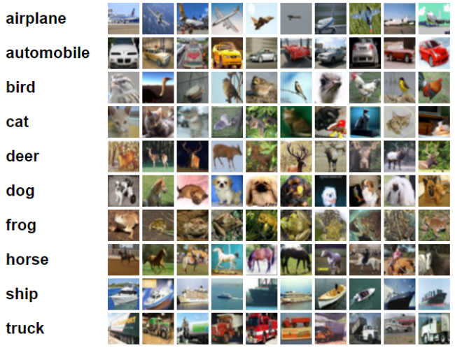תודה ל CIFAR
הרי אותה רשת נוירונים עמוקה הינה אוסף (מיליונים) של פעולות אריתמטיות פשוטות ומוכרות לכולנו שמסודרות בסדר מסוים. משפט אחרון זה אולי נשמע הפשטה לא סבירה למי שלא מכיר, אבל זה באמת מה שיש ברשתות CNN= Convolutional Neural Network:
פעולות חיבור, פעולות כפל ופעולת תנאי (אם מספר גדול מסף מסויים אז תחזיר כך אחרת תחזיר כך)
האם זה כל מה שצריך כדי לתרגם תמונה למספר שמייצג מה רואים בתמונה ?
אין פה שום מתמטיקה כבדה ומסובכת ?
התשובה המאכזבת היא שלא, אין כאן!
אני לא מדבר על איך הגיעו לאותם אוסף פעולות אריתמטיות שפה כן יש מתמטיקה (ואגב ממש לא כבדה), אני מדבר על כך שאחרי שאימנו (איכשהוא) רשת CNN וכעת היא מצליחה לזהות מה רואים בתמונה, מסתבר שכל מה שהיא עושה זה פעולות אריתמטיות פשוטות בסדר מסוים!
מסתבר אפילו שיש הרבה יותר מאפשרות יחידה לסדר את אותם הפעולות האריתמטיות כך שיגרמו לרשת לזהות את התמונה באופן מוצלח. אפשר לאמן את אותה הרשת בכמה פעמים דרכים שונות ויצאו רשתות שונות שכל אחת תדע לזהות היטב.
אז בכל זאת מה עושות אותן מיליוני הפעולות האריתמטיות הללו בכדי לזהות מה רואים בתמונות ?
ראו כלי אינטראקטיבי יפה וויזואלי שמאפשר לראות איך נראית כל תוצאת ביניים של אותם הפעולות האריתמטיות של רשת שיודעת לזהות ספרות בכתב אנושי.
המסקנות של החוקרים של מה הפעולות שהרשת עושה על התמונה כדי לזהות מה רואים בה הם שהפעולות הראשונות (מה שנקרא השכבות הראשונות) מדגישות מאפיינים פשוטים כמו קצוות ושינויי צבע בתמונה בעוד הפעולות הבאות (השכבות הגבוהות שמקבלות כקלט את התוצאות מהפעולות הראשונות) ישלבו את המאפיינים הפשוטים ויסיקו אילו תבניות רואים בתמונה. (למשל אם יש כמה קוים ישרים ושני עיגולים יותר סביר שזה רכב מאשר אדם).
והנה עוד סרטון שסוקר כלי ויזואליזציה נוסף כללי יותר ועם הסברים:
נעיר שכדי לקבל רשת CNN מוצלחת יש לאמן אותה עם עשרות אלפי דוגמאות לפחות של איך אוביקט נראה כדי להצליח לזהות מופע חדש שלו, בעוד לנו בני האנוש מספיקים מאות, עשרות ולעיתים אף מספר בודד של דוגמאות ללמוד איך נראה אוביקט כלשהוא כדי שנזהה אותו.
אבל ההתקדמות לא נעצרת כאן, כי כמה שרשתות CNN קלאסיות השתפרו והן טובות כמו בני אנוש בזיהוי מה רואים בתמונה, מסתבר שהם לא באמת חכמות. למשל את התמונה הבאה כנראה יסווגו כבן אדם רגיל:
https://hackernoon.com/capsule-networks-are-shaking-up-ai-heres-how-to-use-them-c233a0971952 מיקומים יחסיים של מאפיינים בתמונה
הדבר החם בעולם הזיהוי תמונות הגיע מג’פרי הינטון ונקרא Capsule Network (עוד לא ממש ברור איך לתרגם לעברית).
ג’פרי הינטון Geoffrey Hinton מאבות הלמידה העמוקה שהאמין ברשתות נוירונים עוד בשנות השמונים כשרב הקהילה ראתה בזה ענף חסר עתיד. (עיקר הביקורות היו: כשזה כבר כן עובד זה מקרי ואי אפשר להבין למה זה עובד כי זו קופסה שחורה).
דווקא הוא זה שלאחרונה יצא נגד CNN והביא לקהילה בשורה חדשה.
החסרון ב CNN הקלאסי, אותו באו רשתות הקפסולות לפתור הוא שפיצ’רים איבדו את מיקומם היחסי בתמונה כפי שניתן לראות בתמונה למעלה שם אכן יש שתי עיניים, פה ואף אך עדיין זו לא תמונה של פנים אמיתיות. רשתות הקפסולה באים בין השאר לפתור בעיה זו. על רשתות הקפסולות ארחיב בכתבה אחרת.

אלכס-נט
1) https://d2l.ai/chapter_convolutional-modern/alexnet.html

7.1. Deep Convolutional Neural Networks (AlexNet) COLAB

Open the notebook in Colab
Although convolutional neural networks were well known in the computer vision and machine learning communities following the introduction of LeNet, they did not immediately dominate the field. Although LeNet achieved good results on early small datasets, the performance and feasability of training convolutional networks on larger, more realistic datasets had yet to be established In fact, for much of the intervening time between the early 1990s and the watershed results of 2012, neural networks were often surpassed by other machine learning methods, such as support vector machines.
For computer vision, this comparison is perhaps not fair. That is although the inputs to convolutional networks consist of raw or lightly-processed (e.g., by centering) pixel values, practitioners would never feed raw pixels into traditional models. Instead, typical computer vision pipelines consisted of manually engineering feature extraction pipelines. Rather than learn the features, the features were crafted. Most of the progress came from having more clever ideas for features, and the learning algorithm was often relegated to an afterthought.
Although some neural network accelerators were available in the 1990s, they were not yet sufficiently powerful to make deep multichannel, multilayer convolutional neural networks with a large number of parameters. Moreover, datasets were still relatively small. Added to these obstacles, key tricks for training neural networks including parameter initialization heuristics, clever variants of stochastic gradient descent, non-squashing activation functions, and effective regularization techniques were still missing.
Thus, rather than training end-to-end (pixel to classification) systems, classical pipelines looked more like this:
- Obtain an interesting dataset. In early days, these datasets required expensive sensors (at the time, 1 megapixel images were state of the art).
- Preprocess the dataset with hand-crafted features based on some knowledge of optics, geometry, other analytic tools, and occasionally on the serendipitous discoveries of lucky graduate students.
- Feed the data through a standard set of feature extractors such as SIFT, the Scale-Invariant Feature Transform, or SURF, the Speeded-Up Robust Features, or any number of other hand-tuned pipelines.
- Dummp the resulting representations into your favorite classifier, likely a linear model or kernel method, to learn a classifier.
If you spoke to machine learning researchers, they believed that machine learning was both important and beautiful. Elegant theories proved the properties of various classifiers. The field of machine learning was thriving, rigorous and eminently useful. However, if you spoke to a computer vision researcher, you’d hear a very different story. The dirty truth of image recognition, they’d tell you, is that features, not learning algorithms, drove progress. Computer vision researchers justifiably believed that a slightly bigger or cleaner dataset or a slightly improved feature-extraction pipeline mattered far more to the final accuracy than any learning algorithm.

7.1.1. Learning Feature Representation
Another way to cast the state of affairs is that the most important part of the pipeline was the representation. And up until 2012 the representation was calculated mechanically. In fact, engineering a new set of feature functions, improving results, and writing up the method was a prominent genre of paper. SIFT, SURF, HOG, Bags of visual words and similar feature extractors ruled the roost.
Another group of researchers, including Yann LeCun, Geoff Hinton, Yoshua Bengio, Andrew Ng, Shun-ichi Amari, and Juergen Schmidhuber, had different plans. They believed that features themselves ought to be learned. Moreover, they believed that to be reasonably complex, the features ought to be hierarchically composed with multiple jointly learned layers, each with learnable parameters. In the case of an image, the lowest layers might come to detect edges, colors, and textures. Indeed, [Krizhevsky et al., 2012] proposed a new variant of a convolutional neural network which achieved excellent performance in the ImageNet challenge.
Interestingly in the lowest layers of the network, the model learned feature extractors that resembled some traditional filters. Fig. 7.1.1 is reproduced from this paper and describes lower-level image descriptors.
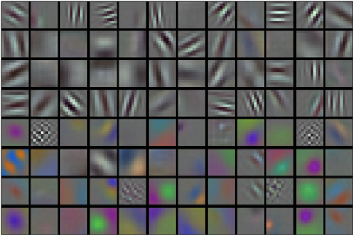
Fig. 7.1.1 Image filters learned by the first layer of AlexNet
Higher layers in the network might build upon these representations to represent larger structures, like eyes, noses, blades of grass, etc. Even higher layers might represent whole objects like people, airplanes, dogs, or frisbees. Ultimately, the final hidden state learns a compact representation of the image that summarizes its contents such that data belonging to different categories be separated easily.
While the ultimate breakthrough for many-layered convolutional networks came in 2012, a core group of researchers had dedicated themselves to this idea, attempting to learn hierarchical representations of visual data for many years. The ultimate breakthrough in 2012 can be attributed to two key factors.

7.1.1.1. Missing Ingredient - Data
Deep models with many layers require large amounts of data in order to enter the regime where they signficantly outperform traditional methods based on convex optimizations (e.g., linear and kernel methods). However, given the limited storage capacity of computers, the relative expense of sensors, and the comparatively tighter research budgets in the 1990s, most research relied on tiny datasets. Numerous papers addressed the UCI collection of datasets, many of which contained only hundreds or (a few) thousands of images captured in unnatural settings with low resolution.
In 2009, the ImageNet dataset was released, challenging researchers to learn models from 1 million examples, 1,000 each from 1,000 distinct categories of objects. The researchers, led by Fei-Fei Li, who introduced this dataset leveraged Google Image Search to prefilter large candidate sets for each category and employed the Amazon Mechanical Turk crowdsourcing pipeline to confirm for each image whether it belonged to the associated category. This scale was unprecedented. The associated competition, dubbed the ImageNet Challenge pushed computer vision and machine learning research forward, challenging researchers to identify which models performed best at a greater scale than academics had previously considered.

7.1.1.2. Missing Ingredient - Hardware
Deep learning models are varacious consumers of compute cycles. Training can take hundreds of epochs, and each iteration requires passing data through many layers of computationally-expensive linear algebra operations. This is one of the main reasons why in the 90s and early 2000s, simple algorithms based on the more-efficiently optimized convex objectives were preferred.
Graphical processing units (GPUs) proved to be a game changer in make deep learning feasible. These chips had long been developed for accelerating graphics processing to benefit computer games. In particular, they were optimized for high throughput 4x4 matrix-vector products, which are needed for many computer graphics tasks. Fortunately, this math is strikingly similar to that required to calculate convolutional layers. Around that time, NVIDIA and ATI had begun optimizing GPUs for general compute operations, going as far as to market them as General Purpose GPUs (GPGPU).
To provide some intuition, consider the cores of a modern microprocessor (CPU). Each of the cores is fairly powerful running at a high clock frequency and sporting large caches (up to several MB of L3). Each core is well-suited to executing a wide range of instructions, with branch predictors, a deep pipeline, and other bells and whistles that enable it to run a large variety of programs. This apparent strength, however, is also its Achilles heel: general purpose cores are very expensive to build. They require lots of chip area, a sophisticated support structure (memory interfaces, caching logic between cores, high speed interconnects, etc.), and they are comparatively bad at any single task. Modern laptops have up to 4 cores, and even high end servers rarely exceed 64 cores, simply because it is not cost effective.
By comparison, GPUs consist of 100-1000 small processing elements (the details differ somewhat between NVIDIA, ATI, ARM and other chip vendors), often grouped into larger groups (NVIDIA calls them warps). While each core is relatively weak, sometimes even running at sub-1GHz clock frequency, it is the total number of such cores that makes GPUs orders of magnitude faster than CPUs. For instance, NVIDIA’s latest Volta generation offers up to 120 TFlops per chip for specialized instructions (and up to 24 TFlops for more general purpose ones), while floating point performance of CPUs has not exceeded 1 TFlop to date. The reason for why this is possible is actually quite simple: first, power consumption tends to grow quadratically with clock frequency. Hence, for the power budget of a CPU core that runs 4x faster (a typical number), you can use 16 GPU cores at 1/4 the speed, which yields 16 x 1/4 = 4x the performance. Furthermore, GPU cores are much simpler (in fact, for a long time they weren’t even able to execute general purpose code), which makes them more energy efficient. Last, many operations in deep learning require high memory bandwidth. Again, GPUs shine here with buses that are at least 10x as wide as many CPUs.
Back to 2012. A major breakthrough came when Alex Krizhevsky and Ilya Sutskever implemented a deep convolutional neural network that could run on GPU hardware. They realized that the computational bottlenecks in CNNs (convolutions and matrix multiplications) are all operations that could be parallelized in hardware. Using two NIVIDA GTX 580s with 3GB of memory, they implemented fast convolutions. The code cuda-convnet was good enough that for several years it was the industry standard and powered the first couple years of the deep learning boom.

7.1.2. AlexNet
AlexNet was introduced in 2012, named after Alex Krizhevsky, the first author of the breakthrough ImageNet classification paper [Krizhevsky et al., 2012]. AlexNet, which employed an 8-layer convolutional neural network, won the ImageNet Large Scale Visual Recognition Challenge 2012 by a phenomenally large margin. This network proved, for the first time, that the features obtained by learning can transcend manually-design features, breaking the previous paradigm in computer vision. The architectures of AlexNet and LeNet are very similar, as Fig. 7.1.2 illustrates. Note that we provide a slightly streamlined version of AlexNet removing some of the design quirks that were needed in 2012 to make the model fit on two small GPUs.

Fig. 7.1.2 LeNet (left) and AlexNet (right)
The design philosophies of AlexNet and LeNet are very similar, but there are also significant differences. First, AlexNet is much deeper than the comparatively small LeNet5. AlexNet consists of eight layers: five convolutional layers, two fully-connected hidden layers, and one fully-connected output layer. Second, AlexNet used the ReLU instead of the sigmoid as its activation function. Let’s delve into the details below.

7.1.2.1. Architecture
In AlexNet’s first layer, the convolution window shape is 11×1111×11. Since most images in ImageNet are more than ten times higher and wider than the MNIST images, objects in ImageNet data tend to occupy more pixels. Consequently, a larger convolution window is needed to capture the object. The convolution window shape in the second layer is reduced to 5×55×5, followed by 3×33×3. In addition, after the first, second, and fifth convolutional layers, the network adds maximum pooling layers with a window shape of 3×33×3 and a stride of 2. Moreover, AlexNet has ten times more convolution channels than LeNet.
After the last convolutional layer are two fully-connected layers with 4096 outputs. These two huge fully-connected layers produce model parameters of nearly 1 GB. Due to the limited memory in early GPUs, the original AlexNet used a dual data stream design, so that each of their two GPUs could be responsible for storing and computing only its half of the model. Fortunately, GPU memory is comparatively abundant now, so we rarely need to break up models across GPUs these days (our version of the AlexNet model deviates from the original paper in this aspect).

7.1.2.2. Activation Functions
Second, AlexNet changed the sigmoid activation function to a simpler ReLU activation function. On the one hand, the computation of the ReLU activation function is simpler. For example, it does not have the exponentiation operation found in the sigmoid activation function. On the other hand, the ReLU activation function makes model training easier when using different parameter initialization methods. This is because, when the output of the sigmoid activation function is very close to 0 or 1, the gradient of these regions is almost 0, so that back propagation cannot continue to update some of the model parameters. In contrast, the gradient of the ReLU activation function in the positive interval is always 1. Therefore, if the model parameters are not properly initialized, the sigmoid function may obtain a gradient of almost 0 in the positive interval, so that the model cannot be effectively trained.

7.1.2.3. Capacity Control and Preprocessing
AlexNet controls the model complexity of the fully-connected layer by dropout (Section 4.6), while LeNet only uses weight decay. To augment the data even further, the training loop of AlexNet added a great deal of image augmentation, such as flipping, clipping, and color changes. This makes the model more robust and the larger sample size effectively reduces overfitting. We will discuss data augmentation in greater detail in Section 13.1.
import d2l
from mxnet import np, npx
from mxnet.gluon import nn
npx.set_np()

net = nn.Sequential()
# Here, we use a larger 11 x 11 window to capture objects. At the same time,
# we use a stride of 4 to greatly reduce the height and width of the output.
# Here, the number of output channels is much larger than that in LeNet
net.add(nn.Conv2D(96, kernel_size=11, strides=4, activation='relu'),
nn.MaxPool2D(pool_size=3, strides=2),
# Make the convolution window smaller, set padding to 2 for consistent
# height and width across the input and output, and increase the
# number of output channels
nn.Conv2D(256, kernel_size=5, padding=2, activation='relu'),
nn.MaxPool2D(pool_size=3, strides=2),
# Use three successive convolutional layers and a smaller convolution
# window. Except for the final convolutional layer, the number of
# output channels is further increased. Pooling layers are not used to
# reduce the height and width of input after the first two
# convolutional layers
nn.Conv2D(384, kernel_size=3, padding=1, activation='relu'),
nn.Conv2D(384, kernel_size=3, padding=1, activation='relu'),
nn.Conv2D(256, kernel_size=3, padding=1, activation='relu'),
nn.MaxPool2D(pool_size=3, strides=2),
# Here, the number of outputs of the fully connected layer is several
# times larger than that in LeNet. Use the dropout layer to mitigate
# overfitting
nn.Dense(4096, activation="relu"), nn.Dropout(0.5),
nn.Dense(4096, activation="relu"), nn.Dropout(0.5),
# Output layer. Since we are using Fashion-MNIST, the number of
# classes is 10, instead of 1000 as in the paper
nn.Dense(10))

We construct a single-channel data instance with both height and width of 224 to observe the output shape of each layer. It matches our diagram above.
X = np.random.uniform(size=(1, 1, 224, 224))
net.initialize()
for layer in net:
X = layer(X)
print(layer.name, 'output shape:\t', X.shape)

conv0 output shape: (1, 96, 54, 54)
pool0 output shape: (1, 96, 26, 26)
conv1 output shape: (1, 256, 26, 26)
pool1 output shape: (1, 256, 12, 12)
conv2 output shape: (1, 384, 12, 12)
conv3 output shape: (1, 384, 12, 12)
conv4 output shape: (1, 256, 12, 12)
pool2 output shape: (1, 256, 5, 5)
dense0 output shape: (1, 4096)
dropout0 output shape: (1, 4096)
dense1 output shape: (1, 4096)
dropout1 output shape: (1, 4096)
dense2 output shape: (1, 10)

7.1.3. Reading the Dataset
Although AlexNet uses ImageNet in the paper, we use Fashion-MNIST here since training an ImageNet model to convergence could take hours or days even on a modern GPU. One of the problems with applying AlexNet directly on Fashion-MNIST is that our images are lower resolution (28×2828×28 pixels) than ImageNet images. To make things work, we upsample them to 244×244244×244 (generally not a smart practice, but we do it here to be faithful to the AlexNet architecture). We perform this resizing with the resize argument in load_data_fashion_mnist.
batch_size = 128
train_iter, test_iter = d2l.load_data_fashion_mnist(batch_size, resize=224)

7.1.4. Training
Now, we can start training AlexNet. Compared to LeNet in the previous section, the main change here is the use of a smaller learning rate and much slower training due to the deeper and wider network, the higher image resolution and the more costly convolutions.
lr, num_epochs = 0.01, 10
d2l.train_ch5(net, train_iter, test_iter, num_epochs, lr)

loss 0.334, train acc 0.878, test acc 0.889
4210.6 examples/sec on gpu(0)

7.1.5. Summary
- AlexNet has a similar structure to that of LeNet, but uses more convolutional layers and a larger parameter space to fit the large-scale dataset ImageNet.
- Today AlexNet has been surpassed by much more effective architectures but it is a key step from shallow to deep networks that are used nowadays.
- Although it seems that there are only a few more lines in AlexNet’s implementation than in LeNet, it took the academic community many years to embrace this conceptual change and take advantage of its excellent experimental results. This was also due to the lack of efficient computational tools.
- Dropout, ReLU and preprocessing were the other key steps in achieving excellent performance in computer vision tasks.

